**A SUMMER TRAINING REPORT**

**On**

**PYTHON**

**Under the Guidance of**

**Mr. Ravi Verma**

**Done By**

**PRACHI RAJPUT**

**BTECH (2nd Year)**

**ROLL NO. 138/18**

**At**



Computer Hardware Company

**SUBMITTED TO**

**[](https://www.google.com/url?sa=i&rct=j&q=&esrc=s&source=images&cd=&ved=2ahUKEwi14p660uXiAhVKT30KHbPZAxQQjRx6BAgBEAU&url=http://www.davietjal.org/logo-b/&psig=AOvVaw2L13tXNHlYNDilgNl70Nki&ust=1560487319602655)**

**Department of Computer Science**

**D.A.V. INTITUTE**

**OF**

**ENGINEERING & TECHNOLOGY**

**KABIR NAGAR, JALANDHAR**

**PROJECT**

**ON**

**BANK MANAGEMENT SYSTEM**



**ABSTRACT**

The Bank Account Management System is an application for maintaining a person's account

in a bank. In this project I tried to show the working of a banking account system and

cover the basic functionality of a Bank Account Management System. To develop a project

The Bank Account Management System is an application for maintaining a person's account

in a bank. In this project I tried to show the working of a banking account system and

cover the basic functionality of a Bank Account Management System. To develop a project

The Bank Account Management System is an application for maintaining a person's account

in a bank. In this project I tried to show the working of a banking account system and

cover the basic functionality of a Bank Account Management System. To develop a project

The Bank Account Management System is an application for maintaining a person's account

in a bank. In this project I tried to show the working of a banking account system and

cover the basic functionality of a Bank Account Management System. To develop a project

The bank management system is an application for maintaining a person's account in a bank. In this project I tried to show the working of banking account system and cover the basic functionality of a bank management system. To develop a project for solving financial applications of a customer in banking environment in order to nurture the needs of an end banking user by providing various ways to perform banking tasks.

The main aim of this project is to develop software for Bank Account Management System. This project has been developed to carry out the processes easily and quickly, which is not possible with the manuals systems, which are overcome by this software. This project is developed using PYTHON language and MYSQL use for database connection. Creating and managing requirements is a challenge of IT, systems and product development projects or indeed for any activity where you have to manage a contractual relationship.

The project analyzes the system requirements and then comes up with the requirements specifications. It studies other related systems and then come up with system specifications. The system is then designed in accordance with specifications to satisfy the requirements.The system design is then implemented with MYSQL and PYTHON . The system is designed as an interactive and content management system. The content management system deals with data entry, validation confirm and updating whiles the interactive system deals with system interaction with the administration and users. Thus, above features of this project will save transaction time and therefore increase the efficiency of the system.

**INTRODUCTION**

The “Bank Account Management System” project is a model Internet Banking Site. This site

The system provides the access to the customer to create an account, deposit/withdraw the cash from his account, also to view reports of all accounts and perform the transactions on account as per their requirements.

The primary aim of this “**Bank Management System**” is to provide an improved design methodology, which envisages the future expansion, and modification, which is necessary for a core sector like banking. This necessitates the design to be expandable and modifiable and so a modular approach is used in developing the application software.

Bank is the place where customers feel the sense of safety for their property. In the bank, customers deposit and withdraw their money. Transaction of money also is a part where customer takes shelter of the bank. Now to keep the belief and trust of customers, there is the positive need for management of the bank, which can handle all this with comfort and ease. Smooth and efficient management affects the satisfaction of the customers and staff members, indirectly. And of course, it encourages management committee in taking some needed decision for future enhancement of the bank.

Now a day’s, managing a bank is tedious job up to certain limit. So software that reduces the

work is essential. Also today’s world is a genuine computer world and is getting faster and

faster day-by-day. Thus, considering above necessities, the software for bank management has became necessary which would be useful in managing the bank more efficiently. All transactions are carried out online by transferring from accounts in the same Bank or international bank. The software is meant to overcome the drawbacks of the manual system.

The software has been developed using the most powerful and secure backend MYSQL

database and the most widely accepted web oriented as well as application oriented.

**SYNOPSIS**

Bank Account Management System keeps the day by day tally record as a complete banking system. It can keep the information of account opening form, Deposit fund, Withdrawal, and Searching the transaction, Individual account opening form, Group Account.

**AIM OF THIS PROJECT**

The main aim of designing and developing this **Bank Management System** PYTHON primarily based Engineering project is to provide secure and efficient net banking facilities to the banking customers. MYSQL database used to develop this bank application where all banking customers details are provided.

.



**Modules**

The Modules description of Bank Management System project. These modules will be developed in PYTHON source code and MYSQL database.

1. **Admin Login Page**
2. **Create New Account**
3. **Account Details Of Customer**
4. **Cashbook Of Customer**
5. **Delete Customer Account**
6. **Update Of Account**
7. **Email To The Customer After Every Update**

**Hardware Requirements Specification**

Processor : Intel Pentium III or later

Main Memory (RAM) : 256 MB

Cache Memory : 512 KB

Monitor : 14 inch Color Monitor

Keyboard : 108 Keys

Mouse : Optical Mouse

Hard Disk : 160 GB

**Software Requirements Specification**

Front End/Language : PYHTON

Back End/Database : MYSQL

Additional Tools : XAPM Server

Operating System : Windows 7, 8, 9, 10, XP

**CODE USE IN PROJECT**

**Modules Used In Python**

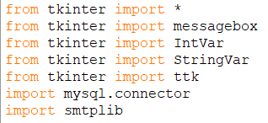

**MYSQL DATABASE USING PYTHON**

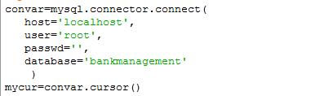

**TKINTER FUNCTION USED**

* Label
* Button
* messagebox
* Entry
* RadioButton
* Sendmail
* TreeView
* Bind
* Place
* Grid
* StringVar
* IntVar

**MYSQL DATABASE TABLE**

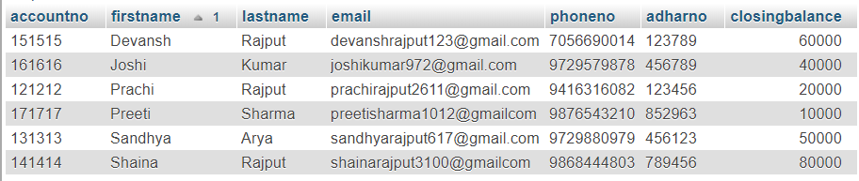

**SCREENSHOTS**

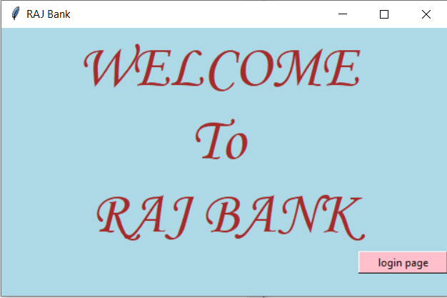

fig 1 FIRST PAGE

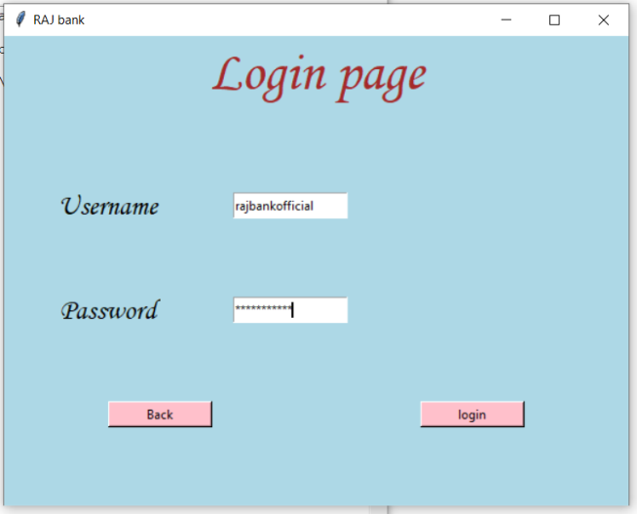

fig 2 LOGIN PAGE

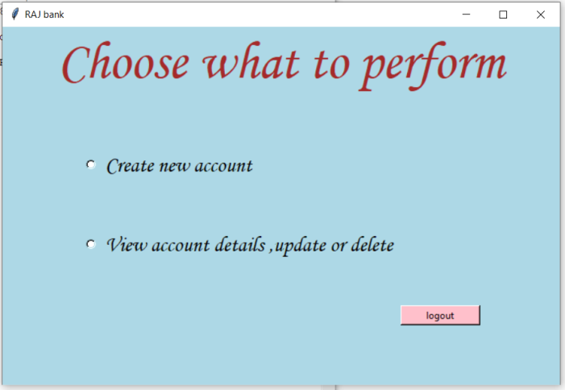

fig 3.1 MAIN MENU

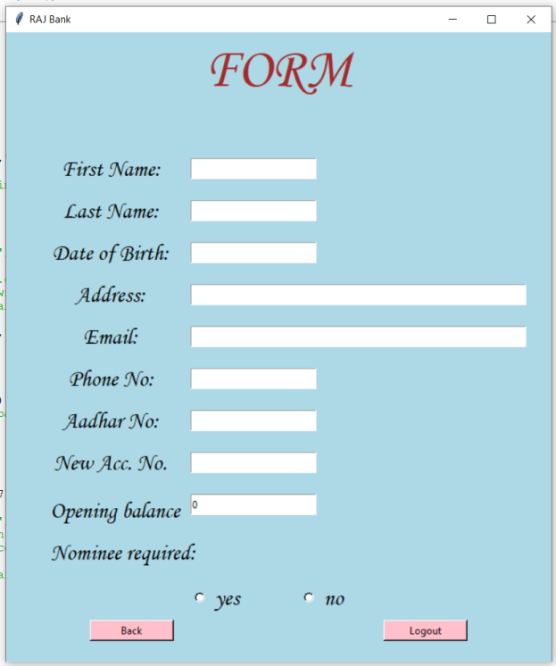

fig3.2 FORM

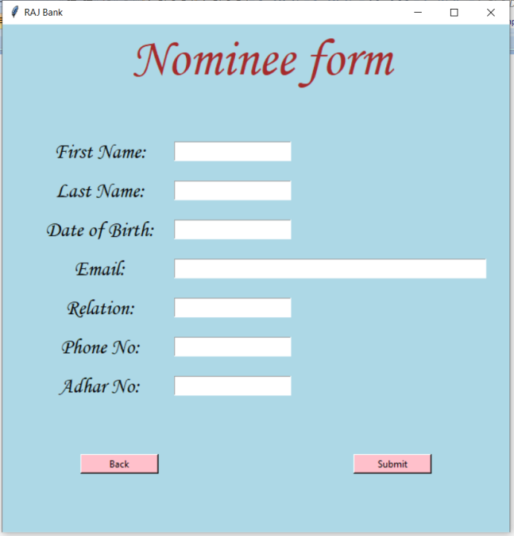

fig 4 FORM

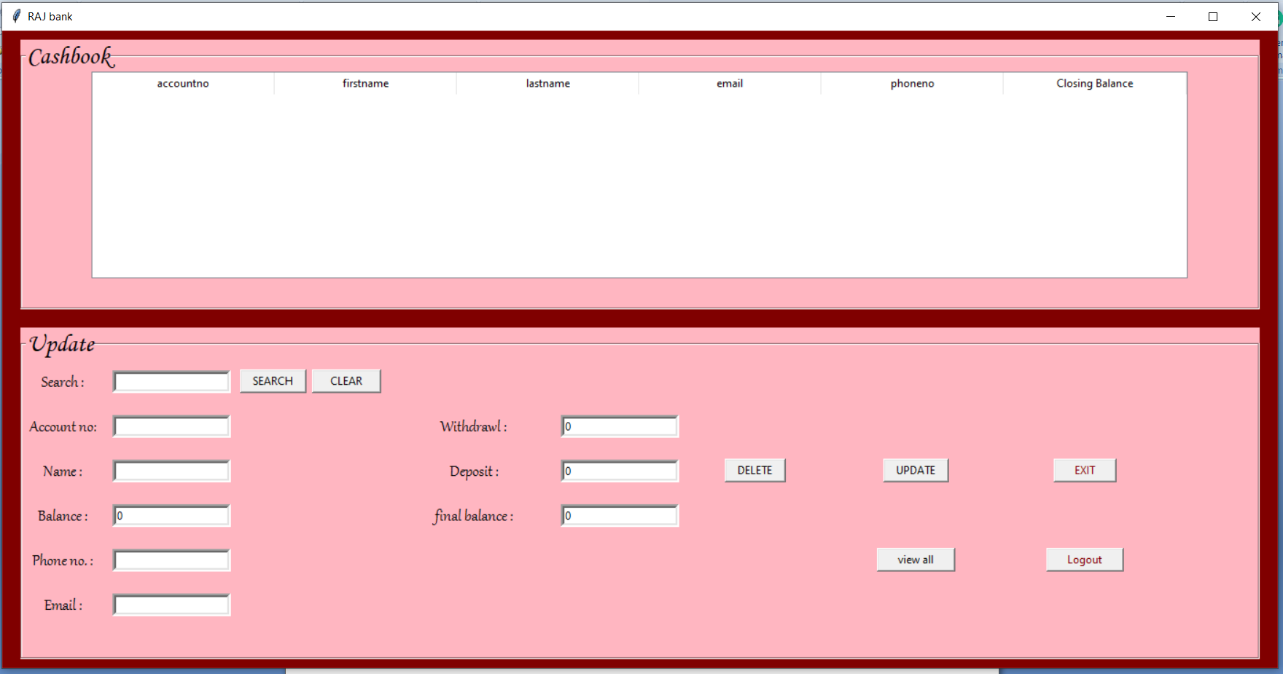

fig 4 CASHBOOK

**MESSAGE BOX**

